PSB Launches Passif 50 Speaker to Celebrate 50 Years
  - Anniversary edition loudspeaker commemorates five decades of award-winning acoustic design

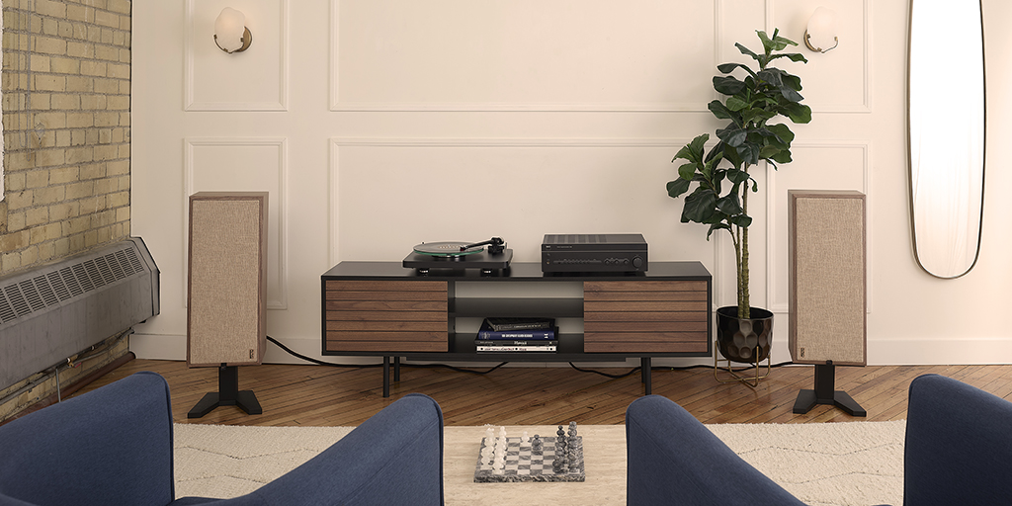
PSB Speakers’ Passif 50 Standmount Loudspeaker Anniversary Edition

July 1, 2022, pickering, canada – PSB Speakers, innovator of high-fidelity speakers since 1972, releases the Passif 50 Anniversary Edition Standmount Loudspeaker in celebration of its 50-year milestone. The design and technologies of the Passif 50 model leverage five decades of dedicated research and pay homage to the early Passif II model first released in 1974. The Passif 50 will be available to pre-order online the first of August with shipping this September, and it retails at USD $2499/GBP $2499/EUR €2999/CAD $3299. As a show of gratitude for the brand’s devoted fanbase, the first 500 units sold of the Passif 50 will contain a handwritten letter from Paul Barton and includes a QR code with an offer to receive a gift pack that includes a cotton canvas backpack, double-walled water bottle, and commemorative keychain.

Capturing a Legacy
In 1974, PSB Founder and Chief Designer Paul Barton developed the Passif II at a time when his initial acoustic research had led to the establishment of PSB’s design philosophy. The Passif II was the first model to incorporate those principals and demonstrate what is now praised as the brand’s signature “True to Nature” sound. Paying tribute to the Passif II, the Passif 50 represents the PSB legacy that has remained strong over 50 years of speaker innovation – a series of products marked by tonal accuracy, spatial realism and freedom from distortion.

Retro-Modern Aesthetic

The Passif 50 features 1970s inspired elements like an open-grained walnut veneer cabinet, magnetically attached woven cloth grilles and dedicated stands. The loudspeaker evokes a sense of nostalgia with its retro details while being constructed with modern materials that align to current tastes. Other unique embellishments include a pull tab on the front grille, which sports the retro PSB logo – originally hand drawn by Paul in his high school geography class – and a rear-panel plaque adorned by a maple leaf with an inscription that reads, “Passif 50 – 1972-2022.”

A Landmark Design

The design of the Passif 50 mirrors its famous 1970’s forefather but incorporates the most current flagship level components and benefits from 50 years of acoustic research. The result is a loudspeaker with classic 70’s looks but achieves a level of performance well beyond the capabilities of its ancestors.

The titanium dome tweeter employs a powerful neodymium magnet and ferrofluid damping, for higher output, improved power handling, and reduced distortion. A phase plug in front of the tweeter’s dome directs the tweeter’s output to ensure a wide and consistent dispersion well beyond the traditional listening window. The result is a speaker which creates a wide and deep soundstage with very acute imaging which isn’t reliant on a precise listening position. A felt pad surrounding the tweeter minimizes edge diffraction for improved transparency and more stable imaging.

The woofer and passive radiator have cast aluminum baskets that resist flexing, and filleted rubber surrounds that dampen cone resonances, resulting in smoother response and reduced distortion. Considerable engineering effort was invested in refining the interaction between the woofer and the passive radiator. The result is a state of perfect balance of their opposing forces.

All joints in the heavily braced enclosure are mitred for improved fit and finish and reduced cabinet vibration. Featuring dual five-way binding posts, the Passif 50 can be bi-wired or bi-amped.

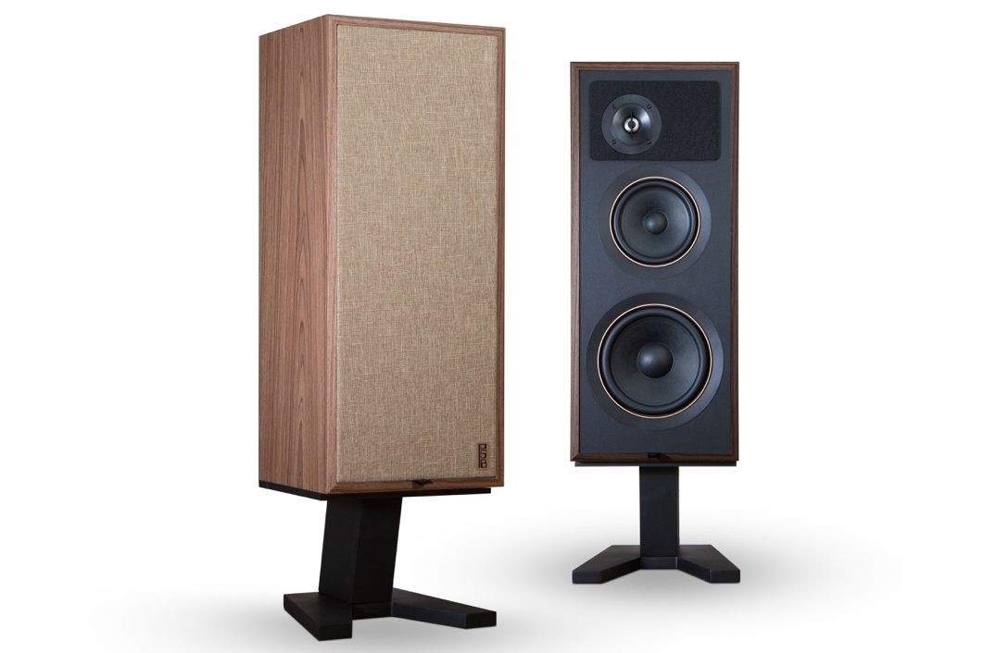
PSB Passif 50 Front-3-4 Pair on Stands - Left Grill on, Right Grille off

Features and Details:
- 1″ titanium dome tweeter with ferrofluid damping and neodymium magnet
- 6.5″ woofer and 8″ passive radiator with cast aluminum baskets, paper cones, and filleted rubber surrounds
- Retro-styled open-grained walnut veneer enclosure and dedicated speaker stands
- Magnetically attached woven cloth grilles
- 50th anniversary design touches, including original PSB logo and pull tab on the grille, and rear-panel plaque that reads “Passif 50 – 1972-2022,” adorned by a maple leaf
- Felt surrounding the tweeter minimizes edge diffraction
- Bi-wirable/bi-ampable five-way gold-plated binding posts
- Speaker alone dimensions: 660mm H x 280mm W x 2540mm D (26” x 11” x 10”)
- Speaker with stand dimensions: 870mm H × 280mm W × 254mm D (34” x 11” x 10”)

About PSB Speakers
Since 1972, Founder and Chief Designer, Paul Barton, has been cementing his legacy as an expert in designing and building high-fidelity speakers that incorporate scientific principles in psychoacoustics. Almost 50 years later and now a strategic part of Lenbrook International’s global portfolio, PSB Speakers’ products are sold in more than 70 markets where the brand sets the standard for “True to Nature” sound and is critically acclaimed for its value-driven and non-fatiguing speaker design. With an expansive suite of products that include audiophile speakers, ANC headphones, powerful and musical subwoofers, and a family of installed speaker solutions, PSB Speakers is designed and built to bring life to recorded music at world class levels.

Contacts

Corporate Contact
June Ip
Marketing
media@psbspeakers.com

US Media Relations
Jeff Touzeau (OLEX Communications – US/Canada)
914-602-2913
jeff@olexcommunications.us

UK Media Relations
Steve Dalton (OLEX Communications – UK)
+44 (0) 7748-117-864
steve@olexcommunications.co.uk

Links
Website: https://psbspeakers.com
Images: https://brandlibrary.lenbrook.com/portals/psbspeakers
Facebook: https://facebook.com/psbspeakers
Twitter: https://twitter.com/psbspeakers
Instagram: https://instagram.com/psbspeakers

# # #

